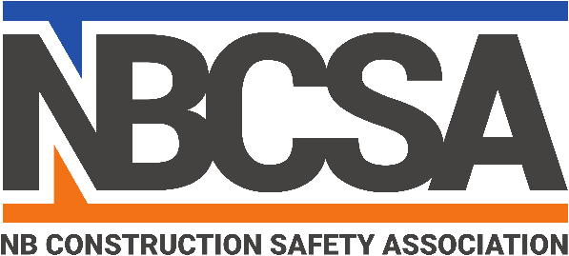
Professional Development Day

Schedule

7:45 – 8:30 | Registration and Breakfast
8:30 – 9:00 | Safety Awards Presentations
9:00 – 9:30 | NBCSA Annual Board Meeting
9:30-10:30 | Return to work- From an employer’s perspective  Lee Mercer, Safety Program Manager, The Miller Group
10:30 – 10:45 | Break
10:45- 12:00 | Safety is common sense - But is it all that common?  Darrell Nickerson, Director of Safety JDI
12:00 – 1:00 | Lunch
1:00- 2:15 | Competency - Exploring case law on the role of employers, contractors and sub-contractors in respect to training and supervision. Michael McGovern, Legal Counsel with WorkSafeNB
2:15 – 2:30 | Break
2:30- 4:00 | Safety is never negotiable - The art of conflict resolution and difficult conversations. Sally Wells, Sally J Wells Inc. Mediation and Legal Training Consultant
4:00- 4:15 | Closing Remarks- Prize Draws
Learning is the only thing that the mind never exhausts, never fears and never regrets
Leonardo da Vinci

